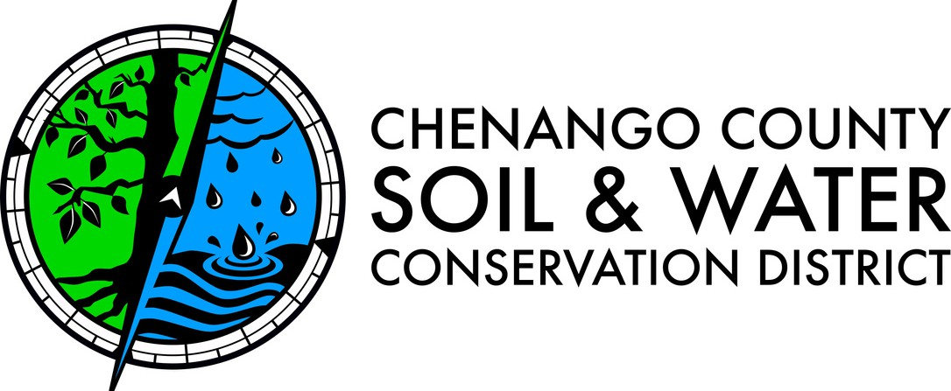
BOARD OF DIRECTORS’ MEETING
1:00 PM THURSDAY, JANUARY 15TH, 2026
USDA CONFERENCE ROOM, 99 NORTH BROAD ST, NORWICH
AGENDA
Call to Order.

Approval of the Minutes.
Payment and Approval of Bills.
Report on Cooperating Agencies.
  - Cornell Cooperative Extension Craig Brown
  - Farm Service Agency Brian Sheridan
  - Natural Resources Conservation Service Eric Fisher
  - Soil and Water Conservation Committee Scott Fickbohm
  - Soil and Water Conservation District Jennifer Kelly
  - Upper Susquehanna Coalition Jennifer Kelly
  - Department of Environmental Conservation Paul Romanenko
  - Fish & Wildlife Management Board
  - Water Quality Coordinating Committee

Old Business.
New Business.
Correspondence.
Adjourn.

The next board meeting is scheduled for February 19, 2026.

